Ultrasound for The Generalist
APPLICATION FORM
www.Generalistultrasound.com

Name:

Grade:

Hospital:

Dietary Preferences:

Experience of Ultrasound
None Some A lot

What 3 things would you like to gain from this course-
1.
2.
3.

Which Days would you like to book on

18th January 2024 - FUSIC/FAMUS Lung/Abdo/Vascular £300

19th January 2024 – FUSIC HEART £300

18th and 19th January 2024 - £550 including US FREE BOOK worth £50

I would like the purchase the US for the Generalist at 40% of RRP £49:99 (£30) Yes
No
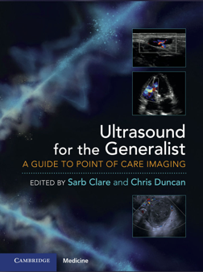
Send back to - swbh.acutemedicalsecretariesamu1@nhs.net

